**Definition: Create the design using the Figma Design Tool, Position, Size, Rotation & corner Radius properties.**

**Solution:**

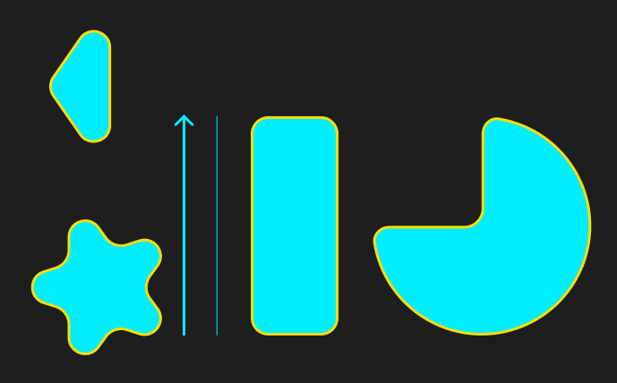

**Steps:**

* First Open Figma in browser mode.
* Then create the new document **File à New Figma Design.**
* Draw 1 Arrow thiswidth=**”250px”**, Rotation=**”90°”** and fill color **”#00EEFF”.**
* Draw 1 Line this width=**”250px”**, Rotation=**”90°”** and fill color **”#00EEFF”.**
* Draw 1 Rectangle this width=**”250px”**, height=**”100px”**, Rotation=**”90°”,** fill color **”#00EEFF”,** Corner-radius=”**20px”.**
* Draw 1 Ellipse this width=”**240px”,** height=”**240px”,** Corner-radius=”**20px”,** Sweep =”**75%”,** Ratio=”**0%”,** Rotation=”**90°”** and fill color **” #00EEFF”.**
* Draw 1 Polygon this width=**”250px”**, height=**”100px”**, Rotation=**”90°”,** fill color “**#00EEFF”,** Corner-radius=”**20px”.**
* Draw 1 Star this width=**”250px”**, height=**”100px”**, Rotation=**”90°”,** fill color **”#00EEFF”,** Corner-radius=”**20px”** and Ratio=”**38.2%”.**
* All shape stroke=**”**3**px”** andcolor **”#FFDD00”.**
* Now, Go to the **Export** button in the property panel. And **Export** it with .**JPG/.PNG** format.